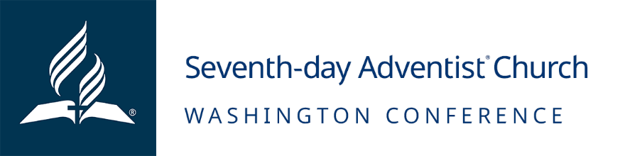
Job Opening: Maintenance Director for Camp Sunset Lake
October 31, 2023
MISSION:
To reach Western Washington with the distinctive, Christ-centered Seventh-day Adventist message of hope and wholeness, encouraging all to become fully devoted disciples of Jesus.

POSITION SUMMARY:
The Maintenance Director plays a pivotal role in ensuring the operational excellence of camp facilities, structures, and vehicles. This position involves assessing the condition of existing buildings and structures, collaborating with the Camp Manager to devise long-term maintenance plans, and guaranteeing a positive guest experience. The role necessitates a high level of maintenance expertise, exceptional organizational skills, and a strong commitment to service.

AUTHORITY AND ACCOUNTABILITY:
The Maintenance Director reports to the Camp Director and directly follows the guidance of the Camp Manager. While there are specific guidelines to adhere to, this role requires the ability to work independently, meet deadlines, and occasionally oversee temporary workers.

ESSENTIAL JOB FUNCTIONS:
- Ensure the upkeep of all existing buildings and infrastructure.
- Collaborate with the Camp Manager to develop a long-term preventative maintenance schedule.
- Execute preventative maintenance tasks.
- Manage work orders and communicate maintenance needs to the manager for prioritization.
- Maintain trails, roads, bridges, and septic systems.
- Partner with experts to monitor forest health, remove hazardous trees, and optimize the forest's recreational and aesthetic appeal.
- Maintain the camp's fleet of vehicles and heavy equipment.
- Provide project cost estimates to assist in building and balancing the camp's annual budget.
- Maintain the workshop in an organized and clean manner.
- Cultivate relationships with local contractors and volunteers for skilled facility work.
- Ensure the camp facility is clean and well-prepared for guest arrivals, as well as clean and closed after departures.
- Assist with snow removal when necessary.
- Conduct routine and preventative maintenance on the vehicle fleet, including quarterly inspections and maintenance tasks.
- Provide guidance and oversight to the summer maintenance team.
- Assist the Camp Manager with larger site or construction projects.
- Undertake other duties as directed by the Camp Manager.

KNOWLEDGE AND SKILLS
- A good understanding of the principles, policies, and beliefs of the Seventh-day Adventist Church and the Washington Conference.
- Proficiency in a wide range of maintenance and construction skills, including project management and organization.
- Ability to work with initiative and minimal supervision.
- Adaptability and prioritization skills.
- Strong communication abilities with all stakeholders.

EDUCATION/EXPERIENCE/CREDENTIALS:
A Bachelor’s (BA/BS) degree is preferred but not required. Prior maintenance experience is preferred.

CONTACTS/ORGANIZATIONAL RELATIONSHIP:
The Maintenance Director interacts with clients, guests, volunteers, and contractors in person, over the phone, and through various communication channels. Exceptional interpersonal skills and effective communication via email and letters are essential. Maintaining confidentiality and supporting the Adventist Church, Washington Conference, and their supervisors is crucial.

SALARY RANGE:
$45,000 – $70,000

BENEFITS:
- Comprehensive well-being programs including medical, dental and vision benefits
- Employee and dependent(s) life insurance
- Long-term disability
- Employer retirement and matching contributions
- Annual bonus
- Holiday and paid time off
ADDITIONAL INFORMATION:
- Apply by 7:00 PM Pacific Time on 12/31/2023
- Employment Type: Full-Time
- FLSA Status: Salaried/Exempt
- Work Location: Camp Sunset Lake, Wilkeson, WA
EQUAL EMPLOYMENT OPPORTUNITY
The Washington Conference of Seventh-day Adventists is an equal opportunity employer and does not discriminate against qualified applicants or employees on account of race, color, sex, age, national origin, marital status, physical or mental disability, or other protected categories under Washington laws, regulations, or local ordinances. The Washington Conference prohibits any form of workplace harassment, misconduct, or abuse. The Washington Conference hires Seventh-day Adventist Church members in good standing based on religious preferences permitted by the United States Constitution and controlling law.

