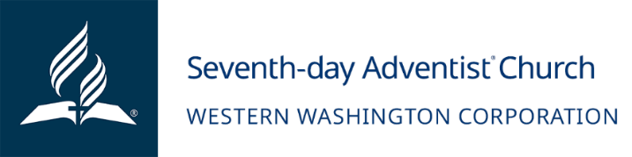
January 8, 2024

Dear Church Board,
WE WELCOME YOUR CHUCH MEMEBERS TO OUR 2024 EMOTIONAL FREEDOM RETREAT RESIDENTIAL PROGRAM
We are writing to invite you to participate in our 2024 sponsorship program. This program aims to provide a weeklong live-in experience for participants at Sunset Lake Camp on October 6 thru 13, 2024.
We are thrilled to announce our third weeklong Emotional Freedom Retreat program, which has been developed over the years since 2018 in collaboration with dedicated health professionals. The cost of this program is $2,500 but the Washington Conference Health Ministries understands the importance of whole-body healing and subsidizes $1,600 leaving an outstanding balance more affordable to $900.00. Through prayer, passion, and extensive planning, we have created a program that incorporates principles, focusing on the 8 laws of health with an emphasis on mental well-being. Our goal is also to assist participants with practical tools so that they achieve a healthier lifestyle using Doctor Neil Nedley’s Depression & Anxiety program, cooking classes, a personal health coach for each participant, exercise classes, lectures, massage and more.
Sunset Lake Camp, a beautiful facility, has partnered with us to provide a conducive environment for this weeklong program. Throughout the retreat, various health professionals will be present, offering a wide range of presentations and resources to support participants on their journey towards improved health.
To ensure inclusivity, we aim to work closely with each participant and their local churches to assist with the cost of lodging, materials, and food, especially for those facing financial hardships. The sponsorship amount requested is up to $900.00 per participant. We kindly request your support with any amount to sponsor one your local church member who would like to complete this health program and is ready to transition to a better health.
By joining us in this sponsorship program, you will provide hope, help cultivate practical healthy habits, and offer a transformative opportunity for the heart, mind, and body of your member. We appreciate your prayers as we launch this year's program and look forward to your positive response.
Thank you for investing in your members overall wellbeing. May God bless you abundantly as you consider supporting our cause with a one-time pledge.
Should you need more information relating to this request, please contact Elida Jerez at 253-250-1646 or email Elida.Jerez@wc.npuc.org.
We look forward in hearing from you soon.
Sincerely,
Elida Jerez

Elida Jerez
Health Ministries Director

